# 

# **Department of Computer Science and Engineering Islamic University of Technology (IUT)** A subsidiary organ of OIC

# **Laboratory Report**

# CSE 4412: Data Communication and Networking Lab

## 

## **Name: Talimul Bari Shreshtho Student ID: 190042128 Section: SWE B Semester: 4th Academic Year: 2021 - 2022**

**Date of Submission:**

### **Title:** Configuration of OSPF in a network topology.

### **Objective**:

1. Understand Link State Routing Protocol
2. Understand OSPF
3. Understand the difference between DV and LS routing

### **Devices/ software Used**:

* + - 1. Cisco Packet Tracer Software
      2. Desktop / Laptop

### **Theory:**

**Link State (LS) Routing:**

The Link state routing algorithm is also known as Dijkstra's algorithm which is used to find the shortest path from one node to every other node in the network. The basic concept of link-state routing is that every node constructs a map of the connectivity to the network, in the form of a graph, showing which nodes are connected to which other nodes. Each node then independently calculates the next best logical path from it to every possible destination in the network. Each collection of best paths will then form each node's routing table.

**Link-State Database (LSDB):**

A router has a separate link state database for every area to which it belongs. The link state database has been referred to elsewhere in the text as the topological database. All routers belonging to the same area have identical topological databases for the area. The LSDB (Link State Database) is the database that OSPF builds and is based on the information that it has found in LSAs (Link State Advertisements). The LSDB is synchronized between routers within the same area.

**Link State Packet:**

A complex routing protocol that shares information with other routers in order to determine the best path. Link State Packet (LSP) is a packet of information generated by a network router in a link state routing protocol that lists the router's neighbors. Link state packets can also be further defined as special datagrams that determine the names of and the cost or distance to any neighboring routers and associated networks. They are used to efficiently determine what the new neighbor is, if a link failure occurs, and the cost of changing a link if the need arises. LSPs are queued for transmission, and must time out at about the same time. They must be acknowledged, and can be distributed throughout the network, but cannot use the routing database.

Least cost tree formation step by step (use more than three nodes)

**Open Shortest Path First (OSPF):**

The OSPF (Open Shortest Path First) protocol is one of a family of IP Routing protocols, and is an Interior Gateway Protocol (IGP) for the Internet, used to distribute IP routing information throughout a single Autonomous System (AS) in an IP network.

**Metric:**

The OSPF metric for a route is the sum of the interface costs for all outgoing interfaces in the route. By default, a router’s OSPF interface cost is actually derived from the interface bandwidth: The faster the bandwidth, the lower the cost. So, a lower OSPF cost means that the interface is better than an interface with a higher OSPF cost.

**Areas:**

By definition an OSPF area is a collection of networks, not a collection of routers. An OSPF network can be divided into sub-domains, called areas. An area is a logical collection of OSPF networks, routers, and links that have the same area identification. A router within an area must maintain a topological database for the area to which it belongs. The router does not have detailed information about network topology outside of its area, which thereby reduces the size of its database.

**Link State Advertisement (LSA):**

Link State Advertisements (LSAs) are messages communicated via multicast to other routers in the OSPF domain. The link-state advertisement (LSA) is a basic communication means of the OSPF routing protocol for the Internet Protocol (IP). It communicates the router's local routing topology to all other local routers in the same OSPF area.

**OSPF Implementation:**

Step 1: Use the command router OSPF process ID to start OSPF.

Step 2: Use the network command to enable the interfaces.

Step 3: Identify area assignments. 

**Performance:**

OSPF protocol is better than the RIP. Unlike RIP protocol that has only 15 hops at most, OSPF has no limitations in hop count. So OSPF converges faster than RIP, and has better load balancing. The drawbacks of OSPF, however, is that it doesn’t scale when there are more routers added to the network

**Update Message:**

Hello: Hello packets are used to discover, build, and maintain OSPF neighbor adjacencies. To establish adjacency, OSPF peers at both sides of the link must agree on some parameters contained in the Hello packet to become OSPF neighbors.

.

Database Description:

These messages contain descriptions of the topology of the AS or area. That is, they convey the contents of the link-state database for the autonomous system or area from one router to another. Communicating a large LSDB may require several messages to be sent. this is done by having the sending device designated as a master device and sending messages in sequence, with the slave (recipient of the LSDB information) responding with acknowledgements.

* + - 1. Link State Request:

These messages are used by one router to request updated information about a portion of the LSDB from another router. The message specifies exactly which link(s) about which the requesting device wants more current information.

1. Link State Update:

These messages contain updated information about the state of certain links on the LSDB. They are sent in response to a Link State Request message, and also broadcast or multicast by routers on a regular basis. Their contents are used to update the information in the LSDBs of routers that receive them.

1. Link State Acknowledgment:

LSAcks are used to make flooding of LSAs reliable. Each LSA received must be explicitly acknowledged. Multiple LSAs can be acknowledged in a single LSAck packet.

**Convergence of Forwarding Tables:**

Convergence is part of the routing table update process. When a link fails or changes, updates are sent across the network that describe changes in the network topology. Convergence is the state of a set of routers that have the same topological information about the internetwork in which they operate. For a set of routers to have converged, they must have collected all available topology information from each other via the implemented routing protocol, the information they gathered must not contradict any other router's topology information in the set, and it must reflect the real state of the network. In other words: In a converged network all routers "agree" on what the network topology looks like

### **Diagram of the experiment:**

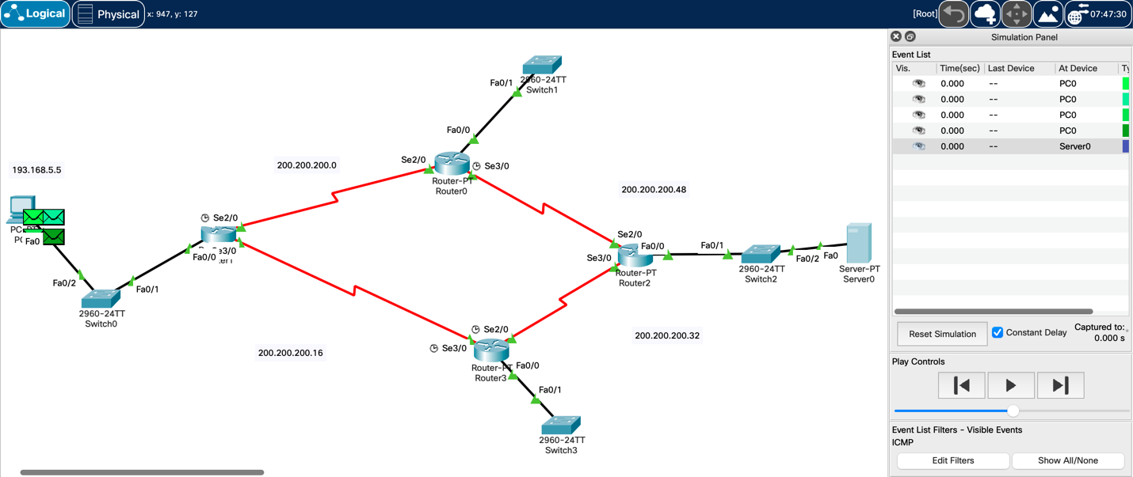

### **Configuration of Routers:**

Commands for configuring OSPF:

Commands for configuring OSPF

Router 0:

Router>en

Router#conf t

Router(config)#router ospf 1

Router(config-router)#network 200.200.200.0 0.0.0.15 area 1

Router(config-router)#network 200.200.200.48 0.0.0.15 area 1

Router(config-router)#network 193.168.11.0 0.0.0.255 area 1

Router(config-router)#exit

Router 1:

Router>en

Router#conf t

Router(config)#router ospf 1

Router(config-router)#network 200.200.200.0 0.0.0.15 area 1

Router(config-router)#network 200.200.200.16 0.0.0.15 area 1

Router(config-router)#network 193.168.5.0 0.0.0.255 area 1

Router(config-router)#exit

Router 2:

Router>en

Router#conf t

Router(config)#router ospf 1

Router(config-router)#network 200.200.200.48 0.0.0.15 area 1

Router(config-router)#network 200.200.200.32 0.0.0.15 area 1

Router(config-router)#network 193.168.10.0 0.0.0.255 area 1

Router(config-router)#exit

Router 3:

Router>en

Router#conf t

Router(config)#router ospf 1

Router(config-router)#network 200.200.200.32 0.0.0.15 area 1 Router(config-router)#network 200.200.200.16 0.0.0.15 area 1

Router(config-router)#network 193.168.6.0 0.0.0.255 area 1

Router(config-router)#exit

### **Observation**:

The screenshots of routing table of each router is shown below:

Router 0 : 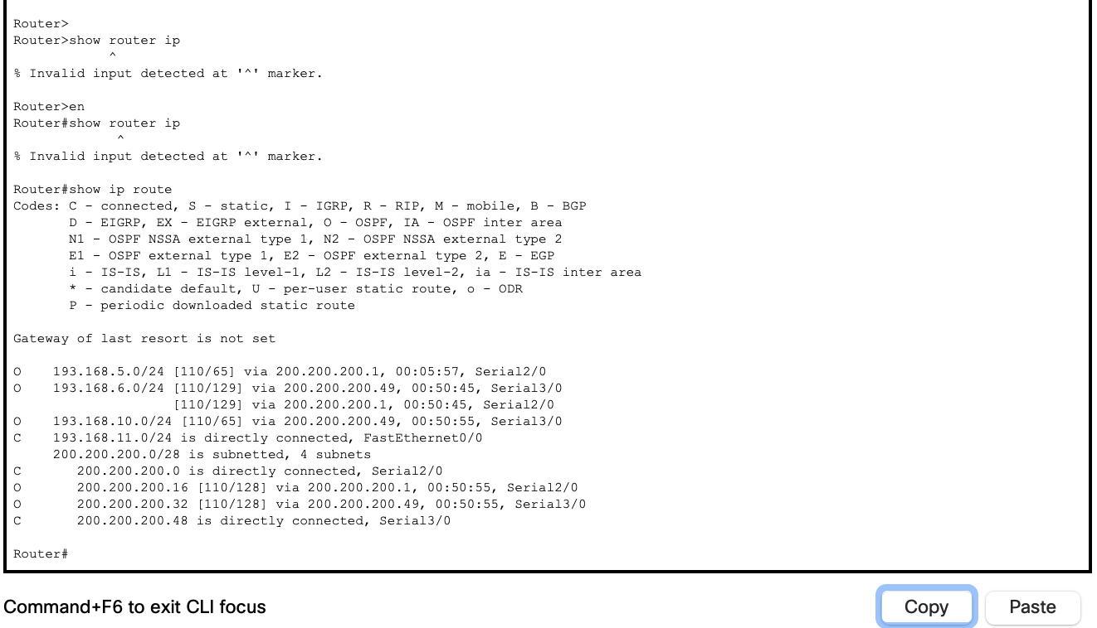

Router 1:

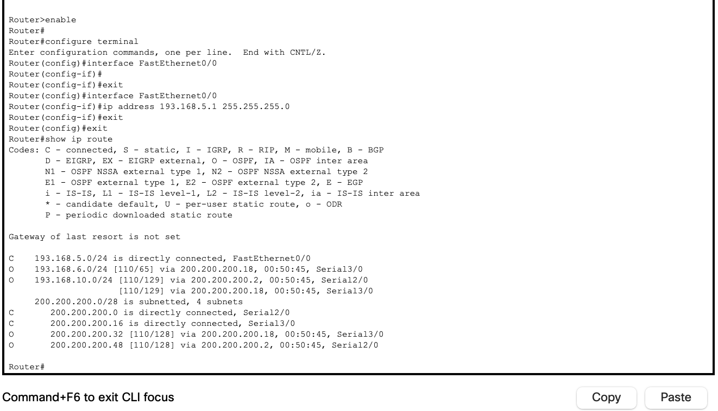

Router 2:

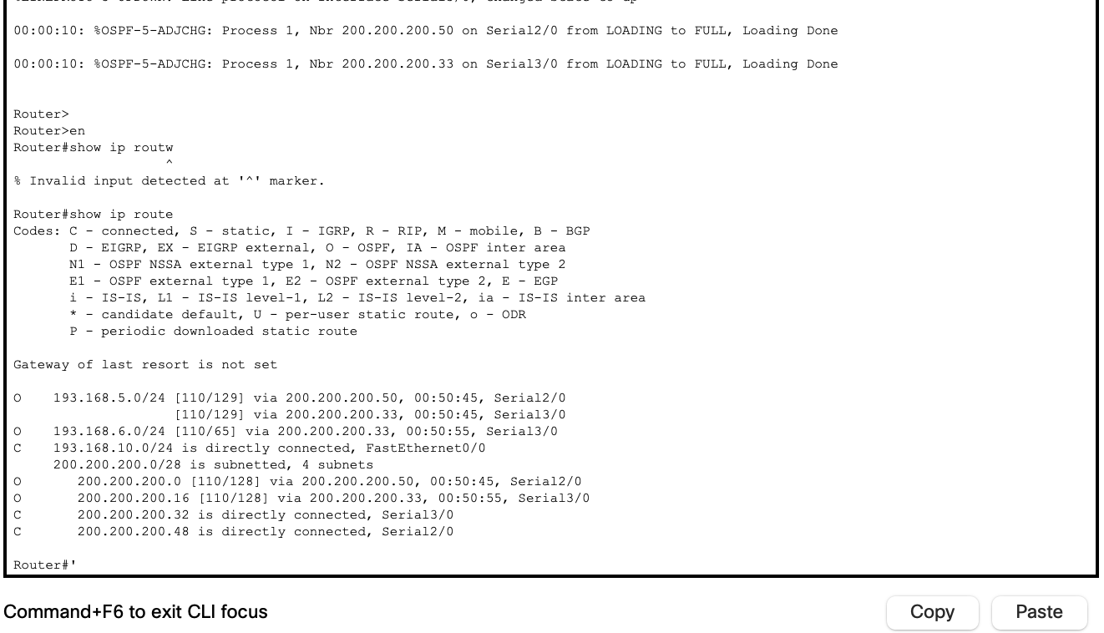

Router 3:

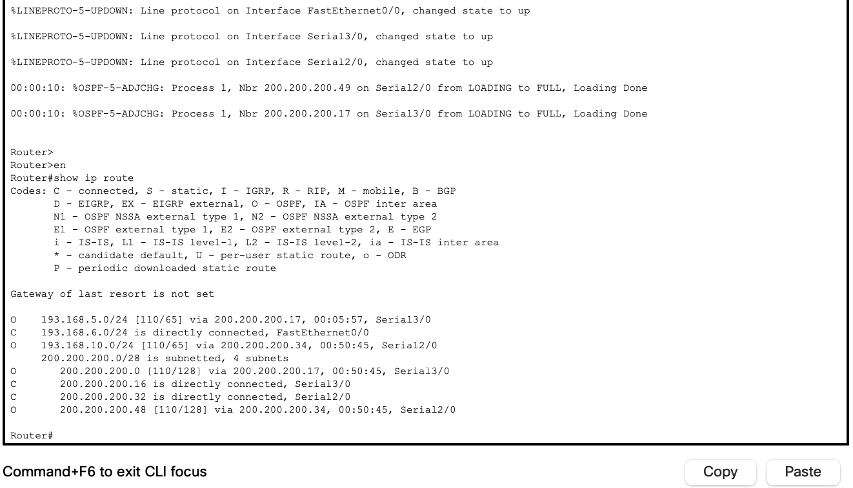

### **Challenges:**

### **Too many ports and ips to configure. All the ips get mixed up . Maintaining too many routers are hard.**